I. INTRODUCTION
A. Description of Theme and Topic Rationale
Backend architecture choices influence how easily a system can be changed, tested, and kept stable over time. In practice, teams often debate whether to keep an application as a monolith or to introduce stronger internal separation through modular or layered design. A monolithic backend can be simpler to build initially, but it can become harder to maintain as features and business rules grow, especially when responsibilities become mixed across the codebase. Research on architectural smells and technical debt highlights that design issues at the architecture level can contribute to reduced maintainability and higher long term effort, which supports the need for clearer architectural structure and evidence based evaluation [1], [2], [3].
This paper focuses on a practical comparison: two backends that provide the same user facing behaviour for a dataset driven case tracking application, but differ internally in architectural structure. The application imports a synthetic JSON dataset into PostgreSQL, validates and normalises the data, logs import runs, and exposes features such as case search, timeline views, and trend summaries. The topic is suitable for a comparative study because the same scope can be implemented in two different ways while controlling other factors, allowing differences in maintainability, testability, and performance to be measured rather than assumed.

B. Positioning and Research Onion
This study is positioned as an applied, controlled software experiment that benchmarks two alternative architecture designs for the same application context. The research philosophy is pragmatism, because the goal is to produce and evaluate a working software artefact and draw conclusions based on measurable outcomes rather than opinion. The research follows a deductive approach, as it tests a predefined hypothesis that a modular or layered architecture leads to better maintainability and testability than a monolithic design.
The research strategy is a controlled software experiment (comparative benchmarking). Two implementations are built with identical requirements, identical dataset ingestion behaviour, and an identical API contract. Evaluation is mono method quantitative, as the main evidence is numerical and comparable across both systems, including complexity metrics, modularity indicators, test coverage, import timing, and API latency. The time horizon is cross sectional with repeated runs, meaning the systems are compared at a single stage of maturity, while repeating measurements to reduce random variation in runtime results.
Recent work indicates that modular monoliths and modular boundaries are being actively discussed and adopted, but there is still a need for clearer evidence and more structured evaluation across contexts [9], [10]. This supports the use of a controlled comparison where architecture is the main factor that changes, and other variables are held constant.
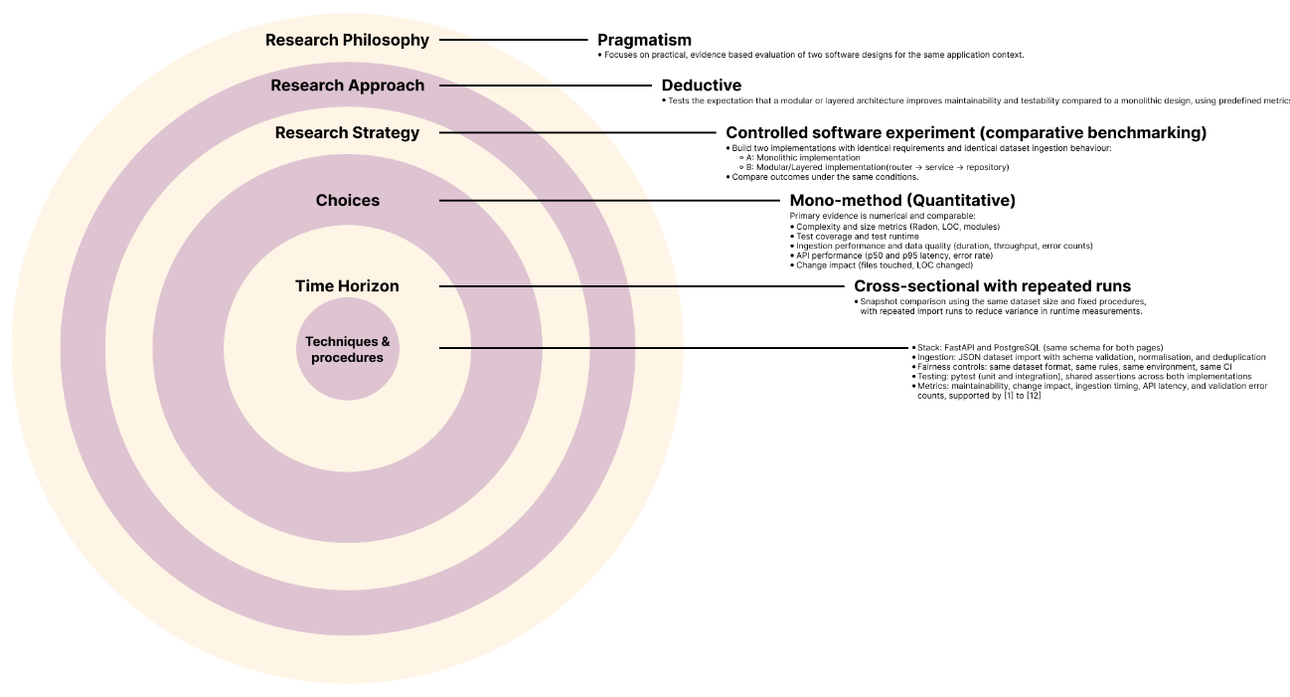Fig 1. Research Onion

C. Background to this Research Theme
Maintainability is widely connected to architecture quality and the presence of architectural smells. Architectural smells are recurring structures that suggest deeper design problems, and mapping studies show growing interest in their detection and management as part of controlling long term system quality [1]. Similarly, knowledge bases for architectural technical debt highlight that architecture decisions can introduce future cost, especially when system boundaries are unclear or when dependencies spread across unrelated areas [2]. Empirical work also links architectural smells to maintainability outcomes, suggesting that architecture is not only a design preference, but a factor that can affect measurable software quality [3].
This is relevant to the monolith versus modular discussion because a key promise of modular or layered design is that boundaries limit the spread of changes, improve test isolation, and reduce the risk that changes create unexpected side effects. Evidence on co changes and architectural smells supports the idea that when files and components tend to change together, systems become harder to evolve predictably, which motivates metrics that capture change propagation and structure quality [7]. In addition, modularity can be measured directly using modularity metrics. For example, M score is proposed as a modularity metric intended to better represent modular structure in real systems, supporting the use of modularity measurement rather than relying only on subjective judgement [8].
Finally, this study uses a dataset ingestion pipeline as the workload because ingestion pipelines highlight data quality issues and validation behaviour, which are important for reliability and performance. Work on data pipeline quality identifies factors and root causes that contribute to data related issues and processing problems, supporting the decision to include data quality indicators such as validation errors and duplicates as part of evaluation [5].

D. Hypothesis, Research Aim, and Purpose Statement (including variables)
Hypothesis: A modular or layered architecture will be more maintainable and more testable than a monolithic architecture.
Research aim: The aim is to compare how a monolithic versus a modular or layered system design influences maintainability, testability, and operational performance in a dataset ingestion pipeline and dashboard, under controlled and identical conditions.
Purpose statement: The purpose of this controlled comparative study is to produce measurable evidence about the impact of backend architectural structure on software quality. This is done by implementing the same case tracking application twice, once as a monolithic backend and once using a modular or layered structure, then evaluating both using the same dataset, database schema, validation rules, test suite, and runtime environment. The study also includes a controlled change request implemented in both versions to measure change impact and assess how architecture affects the effort and risk involved in evolving the system.
Independent and dependent variables (for statistical validation):
When carrying out statistical tests to validate a hypothesis, the independent variable is the factor that is deliberately changed, while the dependent variables are the outcomes that are measured and expected to change as a result. In this study, the independent variable is the backend architecture type, with two levels: (1) monolithic implementation and (2) modular or layered implementation.
The dependent variables are the measured outcomes used to evaluate the hypothesis, including:
- Maintainability and structural complexity, measured using complexity and size metrics, and change impact during a controlled change request (files touched, lines of code changed, modules affected) [6], [7].
- Testability, measured using unit test coverage of key ingestion and business rules, and integration test stability and runtime [11].
- Operational performance, measured using import duration, throughput, validation error counts, and API latency and error rate under fixed load [5].
These variables allow the hypothesis to be evaluated using comparable measurements while keeping other factors controlled.

